Design a menu structure for ordering house- hold items from a mall directly to your home through a mobile phone interface. Categorize the items into menus and submenus. (make use of Hick’s Law)

Aim: To Design a menu structure for ordering house- hold items from a mall directly to your home through a mobile phone interface.

CODING:

<!DOCTYPE html>

<html>

<head>

<title>Household Items Ordering Menu</title>

<style>

/\* Basic styling for the menu \*/

ul {

list-style-type: none;

}

li {

padding: 10px;

}

.submenu {

display: none;

}

/\* Show submenus on hover \*/

li:hover .submenu {

display: block;

}

</style>

</head>

<body>

<h1>Household Items Ordering Menu</h1>

<ul>

<li>Electronics

<ul class="submenu">

<li>TV</li>

<li>Refrigerator</li>

<li>Washing Machine</li>

</ul>

</li>

<li>Furniture

<ul class="submenu">

<li>Sofa</li>

<li>Bed</li>

<li>Dining Table</li>

</ul>

</li>

<li>Kitchen Appliances

<ul class="submenu">

<li>Microwave Oven</li>

<li>Coffee Maker</li>

<li>Toaster</li>

</ul>

</li>

<li>Home Decor

<ul class="submenu">

<li>Rugs</li>

<li>Curtains</li>

<li>Wall Art</li>

</ul>

</li>

</ul>

</body>

</html>

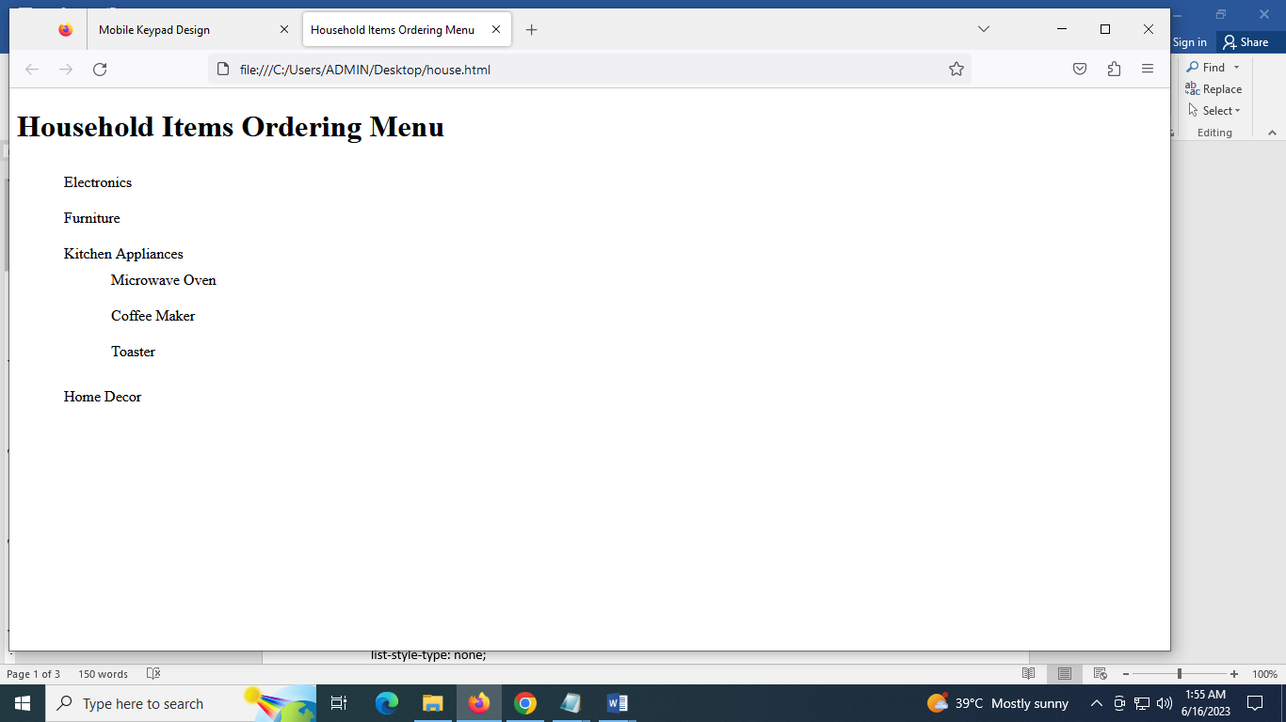

Result:Thus a menu structure for ordering house- hold items from a mall directly to your home through a mobile phone interface was designed successfully.